# Main Formulas

# Example 1 (Gravity only on steel ball)

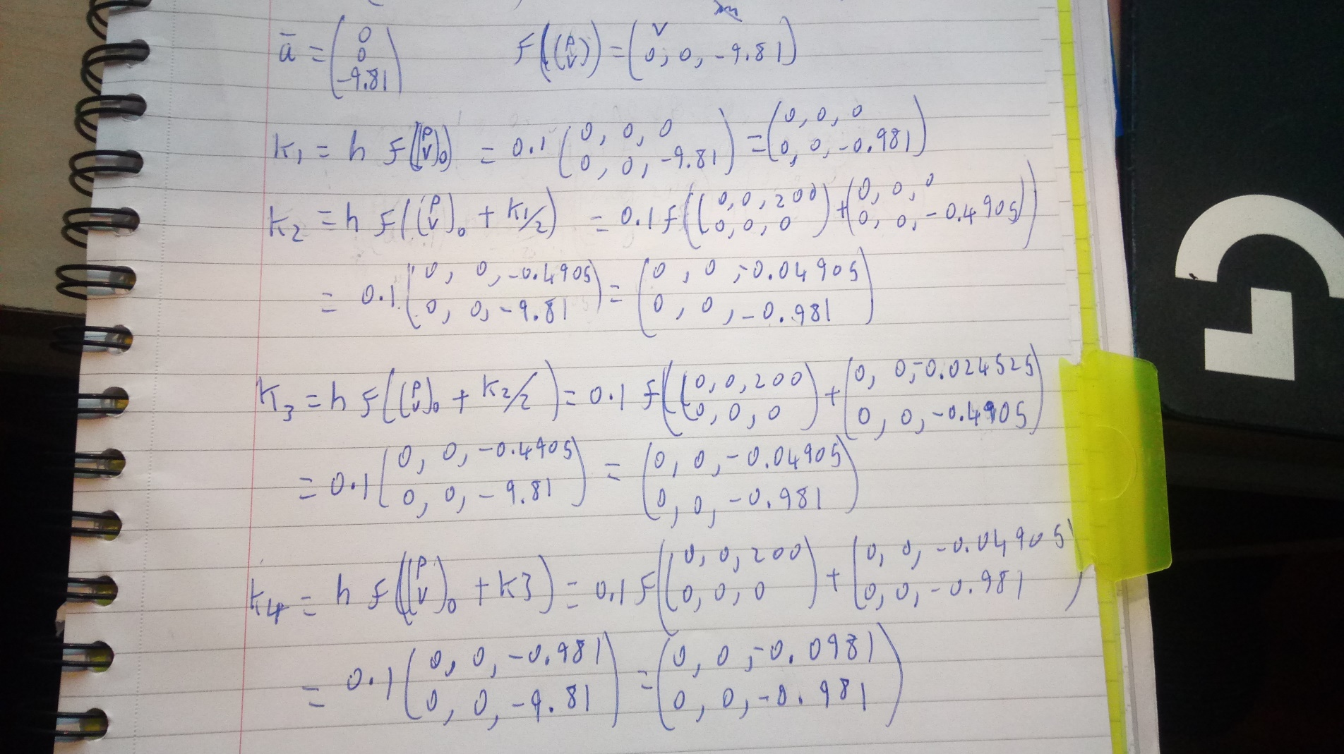Rk4 is only done on example 1 as the non-gravity forces require velocity which changes through out the rk4 method.

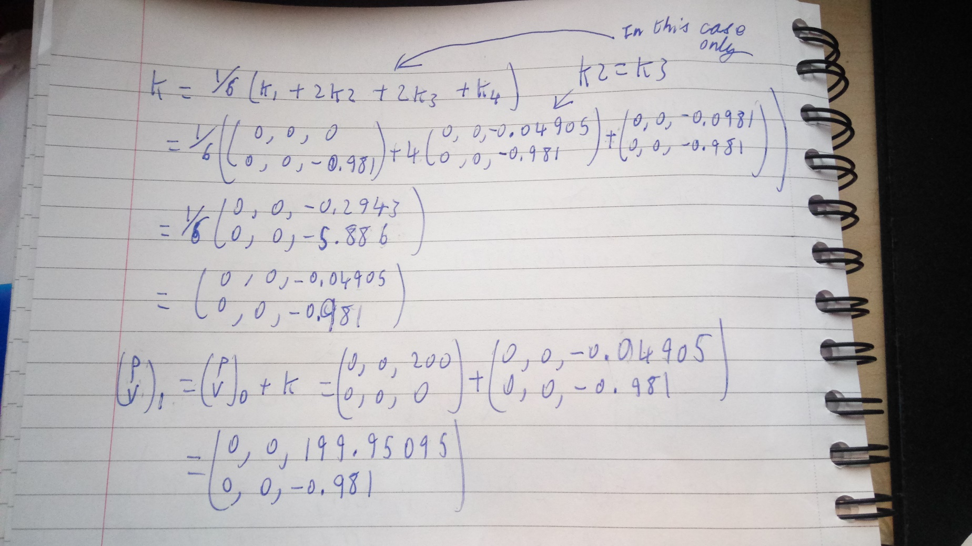

# Example 2 (Cannon ball)

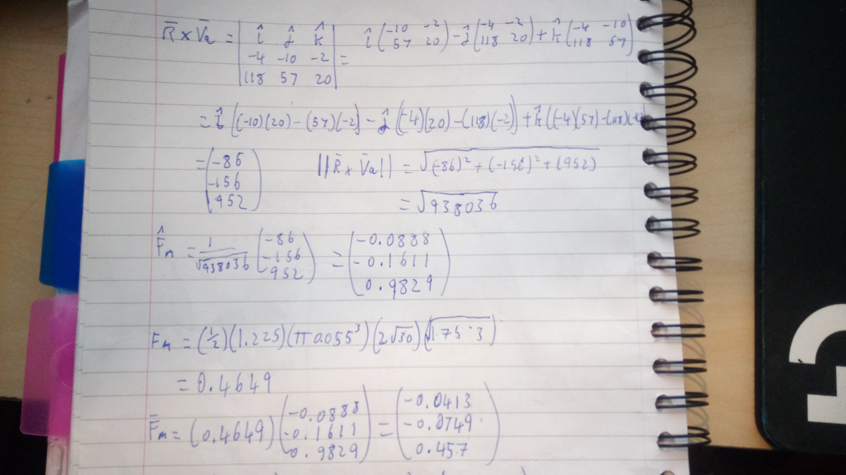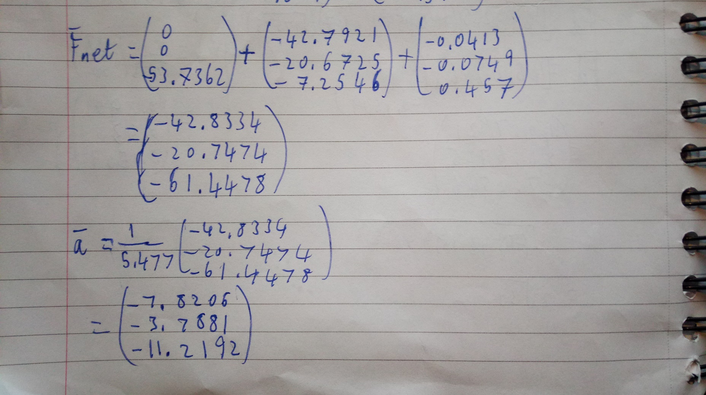

# Example 3 (Basketball throw)

